Assignment 2

1. Tell us about the features of client/server.

* In client server computing, the clients requests a resource and the server provides that resource. Therefore it can be said that system works in request and response form.
* The client-server follows common communication protocol to interact with each other. All the communication protocols are available at the application layer.
* All data is centralized on single server, simplifying security checks and updates data and software.
* A server can only accommodate a limited number of client requests at a time. So it uses a system based to priority to respond to the requests.
* Denial of Service attacks hinders server’s ability to respond to authentic client requests by inundating it with false requests.

1. What is a Web server in a client server environment?

Client–servermodel is a [distributed application](https://en.wikipedia.org/wiki/Distributed_application) structure that partitions tasks or workloads between the providers of a resource or service, called [servers](https://en.wikipedia.org/wiki/Server_(computing)), and service requesters, called [clients](https://en.wikipedia.org/wiki/Client_(computing)).

"Web server" can refer to hardware or software, or both of them working together.

* On the hardware side, a web server is a computer that stores web server software and a website's component files. It is connected to the Internet and supports physical data interchange with other devices connected to the web.
* On the software side, a web server includes several parts that control how web user’s access hosted files, at minimum an HTTP server. An HTTP server is a piece of software that understands [URLs](https://developer.mozilla.org/en-US/docs/Glossary/URL) and [HTTP](https://developer.mozilla.org/en-US/docs/Glossary/HTTP) .It can be accessed through the domain names of websites it stores, and delivers their content to the end-user's device

1. What is the role of the presentation layer?

* The presentation layer is responsible for the formatting and delivery of information to the application layer for further processing or display.
* As the translator, the presentation layer converts the data sent by the application layer of the transmitting node into an acceptable and compatible data format based on the applicable network protocol and architecture
* Encryption is needed for security purposes when sending data across networks. An encryption algorithm is used during transmission, while a decryption algorithm is used at the receiving node. Encryption and decryption typically involves the secure sockets layer (SSL) protocol, which has become more popular when used by the presentation layer.
* Data Compression, by reducing the number of bits requiring transmission, which improves the data throughput.
* Networks provide the capability of connecting different types of computers, servers and mainframes on the same network and may employ different character sets. The presentation layer is responsible for fixing any irregularities while making translations transparent between networked systems.
* They say this architecture is secure, how is it done in your opinion?

4.They say this architecture is secure, how is it done in your opinion?

Client-server architecture provides a convenient way to interconnect distributed applications,

more important, it is basic architecture of the Internet .In open environment of the internet,

security and reliability are difficult to achieve.

Client server architecture involves multiple clients connecting to atleast one central server.

When clients need access to these resources, they access them from the server.

Client-server networks tend to have faster access speeds because of the .It is easier

To upgrade software applications and files. Security is enhanced on client server

Network because the security is handled by the server.

The firewall set between client and server architecture provides security. Firewall act as a

barrier between server and the network, preventing unauthorised access to server and network,

as well as intruders from exploiting server vulnerabilities.

1. What is a Database Server in a client server environment?

The database server includes the data persistence mechanisms (database servers, file shares, etc.) and the data access layer that encapsulates the persistence mechanisms and exposes the data. The data access layer should provide an api to the application tier that exposes methods of managing the stored data without exposing or creating dependencies on the data storage mechanisms. Avoiding dependencies on the storage mechanisms allows for updates or changes without the application tier clients being affected by or even aware of the change. As with the separation of any tier, there are costs for implementation and often costs to performance in exchange for improved scalability and maintainability.

1. Explain two-tier and three-tier architecture

The two-tier is based on Client Server architecture. The two-tier architecture is like client server application. The direct communication takes place between client and server. There is no intermediate between client and server. Because of tight coupling a 2 tiered application will run faster.

Client sends the request to server and it process the request & send back with data. The main problem of two tier architecture is the server cannot respond multiple request same time, as a result it cause a data integrity issue.

Fig. two tier architecture

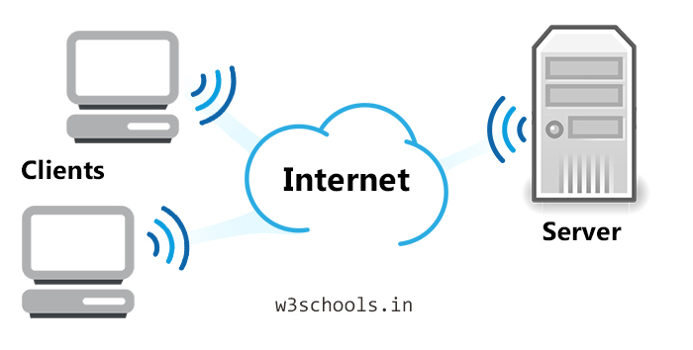

A three-tier client/server is a type of multi-tier computing architecture in which an entire application is distributed across three different computing layers or tiers. It divides the presentation, application logic and data processing layers across client and server devices.

Following are the different tiers

* The **presentation layer** displays information related to such services as browsing merchandise, purchasing and shopping cart contents. It communicates with other tiers by which it puts out the results to the browser/client tier and all other tiers in the network.
* The **application layer** also called logical tier is pulled out from the presentation tier and, as its own layer, it controls an application’s functionality by performing detailed processing.
* The **database layer** includes the data persistence mechanisms (database servers, file shares, etc.) and the data access layer that encapsulates the persistence mechanisms and exposes the data. The data access layer should provide an api to the application tier that exposes methods of managing the stored data without exposing or creating dependencies on the data storage mechanisms.

1. What is file server?

In the [client/server](https://searchnetworking.techtarget.com/definition/client-server) model, a file server is a computer responsible for the central storage and management of [data](https://searchdatamanagement.techtarget.com/definition/data) files so that other computers on the same network can access the files. A file server allows users to share information over a [network](https://searchnetworking.techtarget.com/definition/network) without having to physically transfer files by floppy diskette or some other external storage device. Any computer can be configured to be a [host](https://searchnetworking.techtarget.com/definition/host) and act as a file server. In its simplest form, a file server may be an ordinary PC that handles requests for files and sends them over the network. In a more sophisticated network, a file server might be a dedicated network-attached storage (NAS) device that also serves as a remote [hard disk drive](https://searchstorage.techtarget.com/definition/hard-disk-drive) for other computers, allowing anyone on the network to store files on it as if to their own hard drive.

A file server may be dedicated or non-dedicated. A dedicated server is designed specifically for use as a file server, with workstations attached for reading and writing files and databases.

File servers may also be categorized by the method of access: Internet file servers are frequently accessed by [File Transfer Protocol](https://en.wikipedia.org/wiki/File_Transfer_Protocol) or by [HTTP](https://en.wikipedia.org/wiki/HTTP) (but are different from that often provide dynamic web content in addition to static files). Servers on a LAN are usually accessed by [SMB](https://en.wikipedia.org/wiki/Server_Message_Block)/[CIFS](https://en.wikipedia.org/wiki/CIFS) protocol ([Windows](https://en.wikipedia.org/wiki/Microsoft_Windows) and [Unix-like](https://en.wikipedia.org/wiki/Unix-like)) or [NFS](https://en.wikipedia.org/wiki/Network_File_System_(protocol)) protocol (Unix-like systems).